

**DATA VISUALIZATION**

**Life Expectancy Across the Globe: Investigating the Impact of BMI, GDP, Health-related Factors, Vaccination Coverage.**

***By:***

***SHILPI KUMARI***

***U50191812***

[***kumari42@usf.edu***](mailto:kumari42@usf.edu)

# **Introduction**: The overall health and well-being of individuals across the world are influenced by a multitude of factors, including life expectancy, nutrition, vaccination coverage, and socioeconomic indicators. Understanding the relationships between these factors is crucial for policymakers and public health organizations to identify and address health disparities and improve the quality of life for people worldwide.

In recent decades, life expectancy has become an important measure of a nation's overall health and quality of life. Understanding the key drivers behind differences in life expectancy between countries can help inform policy decisions and public health interventions aimed at improving health outcomes for all.

In this project, I aim to analyze the various factors affecting life expectancy across different countries and their impact on overall health and well-being. I will focus on multiple aspects, such as vaccination coverage, urban and rural population percentages, alcohol consumption, total health expenditure, and key health indicators like HIV/AIDS, Hepatitis B, Measles, Polio, and Diphtheria. Additionally, I will examine the trends in infant mortality rates over time. By exploring these diverse elements, I will gain a deeper understanding of the complex interplay between these factors and their influence on life expectancy, enabling us to identify potential areas for intervention and improvement. Our analysis will be based on a comprehensive data set, covering a wide range of countries, providing valuable insights into the global landscape of life expectancy and its underlying determinants.

This project aims to contribute to a better understanding of global health trends and inform decision-makers, researchers, and the public about the vital importance of addressing the factors that impact life expectancy. Ultimately, our goal is to help promote healthier, longer lives for people around the world.

**Research Questions:**

1)What is the relationship between life expectancy and vaccination coverage (BCG, MCV1, Pol3, DTP3) in different countries?

2)How does the percentage of urban and rural population impact life expectancy in different countries?

3)How do alcohol consumption and total expenditure on health impact life expectancy in different countries?

4)Which health indicators (HIV/AIDS, Hepatitis B, Measles, Polio, Diphtheria) have the most significant impact on life expectancy?

5)How has the infant mortality rate changed over time for different countries?

**Methodology:**Data Collection and Preparation:

Gather the required datasets from reliable sources,

life expectancy data: <https://www.kaggle.com/datasets/kumarajarshi/life-expectancy-who>

global food: https://ourworldindata.org/food-supply

urban and rural population: [Urbanization - Our World in Data](https://ourworldindata.org/urbanization)

Global Vaccination Coverage: [Vaccination - Our World in Data](https://ourworldindata.org/vaccination)  
Gross domestic product: [Gross domestic product (GDP), 2020 (ourworldindata.org)](https://ourworldindata.org/grapher/gross-domestic-product)  
Life expectancy vs GDP per capita: [Life expectancy vs. GDP per capita, 2018 (ourworldindata.org)](https://ourworldindata.org/grapher/life-expectancy-vs-gdp-per-capita)

b. Clean and preprocessed the data by removing any inconsistencies, missing values, or outliers that may impact the analysis.

c. Combine the datasets into a single, comprehensive dataset that contains all relevant information for the analysis.

Data Exploration:

a. Performed a descriptive analysis of the dataset to understand the distribution of variables, identify any trends or patterns, and gain insights into the data.

b. Visualize the data using Tableau to explore relationships between life expectancy and various factors, such as BMI, vaccination coverage, and urbanization.

Data Analysis:

a. Formulate research questions based on the initial data exploration.

b. Conduct a more in-depth analysis using Tableau to answer these research questions or test the hypotheses.

Interpretation and Conclusion:

a. Summarize the key findings from the data analysis and discuss their implications for global health trends and life expectancy.

b. Conclude the factors that contribute to life expectancy.

## **ANALYSIS:** Before getting into the research questions, let’s have a look at the basic analysis of life expectancy.**

This preliminary analysis provided a global overview of life expectancy, focusing on several key countries to highlight the variation in life expectancy rates. In the United States, the average life expectancy is 78.06 years, while in Australia, it is slightly higher at 81.81 years. In India, the average life expectancy is considerably lower at 65.24 years. Canada's life expectancy is similar to Australia's at 81.69 years, and Russia falls in between the other countries with a life expectancy of 67.76 years. This snapshot of life expectancy across these diverse nations underscores the need for further investigation into the factors contributing to these differences and the potential interventions that could improve overall health and well-being.  
  
🡪Per capita GDP and Life Expectancy for every year.

Our analysis explored the relationship between per capita GDP and life expectancy. A positive correlation between these two factors indicates that countries with higher per capita GDP generally have longer life expectancies.

In 2005, Qatar exhibited the highest GDP per capita, accompanied by a life expectancy of 76.60 years. In contrast, despite having a much lower GDP per capita of 4,729, Italy boasted a higher life expectancy of 88 years. On the other end of the spectrum, Sierra Leone had both the lowest GDP per capita and the lowest life expectancy.

Per capita GDP and life expectancy are often positively correlated, meaning that as the per capita GDP of a country increases, so does its life expectancy. This is because a higher per capita GDP usually indicates a higher standard of living and better access to resources, which can contribute to longer and healthier lives.

However, it's essential to understand that the relationship is not always linear, and other factors can influence life expectancy. These factors may include:

Access to quality healthcare, Education, Social determinants of health, Nutrition, Environmental factors, and many more. While there is a generally positive relationship between per capita GDP and life expectancy, it is crucial to consider the interplay of these factors and recognize that higher GDP per capita does not always guarantee a longer life expectancy. Other social, economic, and environmental factors must be considered when evaluating the overall health and well-being of a country's population.  
  
  
**1) What is the relationship between life expectancy and vaccination coverage (BCG, MCV1, Pol3, DTP3) in different countries?**  
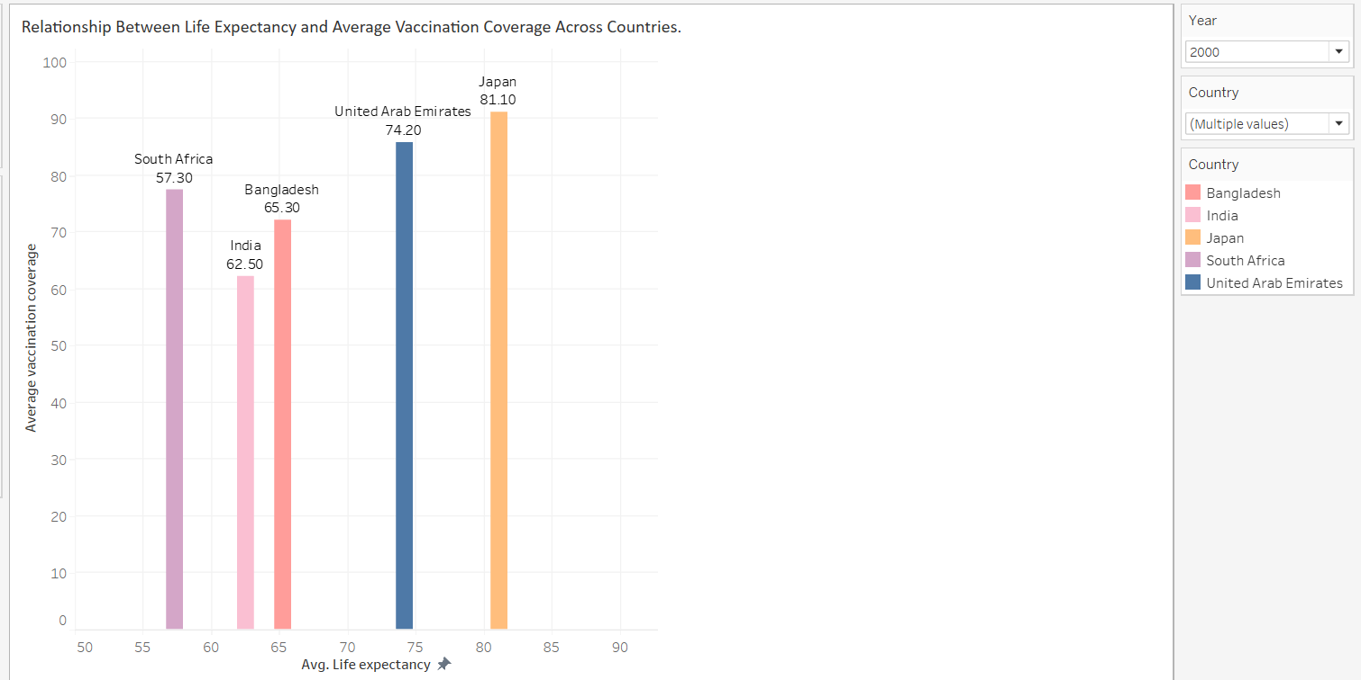

The relationship between life expectancy and vaccination coverage (BCG, MCV1, Pol3, DTP3) in different countries can be analyzed by examining the trends and associations between these variables. Here's a potential analysis of this relationship:  
  
Here, I have taken the average of the immunization and used a bar chart, as it’s clear to understand

Vaccination coverage is a crucial factor in improving public health and increasing life expectancy. Vaccines protect against various infectious diseases, such as tuberculosis (BCG), measles (MCV1), polio (Pol3), and diphtheria-tetanus-pertussis (DTP3). Widespread immunization helps reduce the incidence of these diseases, which can lead to a decline in morbidity and mortality rates, ultimately resulting in increased life expectancy.

Our analysis of the relationship between life expectancy and vaccination coverage in different countries shows that countries with higher vaccination coverage tend to have higher life expectancy rates. This positive correlation suggests that increased immunization efforts play a significant role in enhancing overall health and longevity.

However, it is essential to note that the relationship between vaccination coverage and life expectancy may not be solely causal. Other factors, such as access to healthcare, nutrition, education, and socioeconomic conditions, also contribute to life expectancy rates. Nevertheless, the positive association between vaccination coverage and life expectancy indicates the importance of investing in robust immunization programs to improve public health and increase life expectancy.

In 2000, India had a life expectancy of 62.5 years and average vaccination coverage of 62.11%. By 2015, the life expectancy in India increased to 68 years. This improvement in life expectancy may be partially attributed to advancements in vaccination coverage during this period.

In 2000, South Africa had a life expectancy of 57.3 years and average vaccination coverage of 77.41%. By 2015, the life expectancy in South Africa increased to 62.9 years. This improvement in life expectancy may be partially attributed to advancements in vaccination coverage during this period.

On the other hand, countries with lower vaccination coverage tend to experience higher morbidity and mortality rates from vaccine-preventable diseases, which negatively impacts life expectancy.

In conclusion, our analysis demonstrates a positive relationship between life expectancy and vaccination coverage in different countries. While other factors may influence life expectancy, vaccination coverage remains a critical component in the overall health and well-being of a population. Ensuring high vaccination coverage rates is essential for reducing the burden of infectious diseases and enhancing life expectancy worldwide.

The relationship between life expectancy and vaccination coverage. Our analysis shows a positive correlation between vaccination coverage rates for BCG, MCV1, Pol3, and DTP3, and life expectancy in different countries. This suggests that as vaccination coverage increases, life expectancy is likely to improve, highlighting the importance of immunization programs in promoting health and preventing diseases.

**2)How does the percentage of urban and rural population impact life expectancy in different countries?**

The impact of the urban and rural population percentage on life expectancy varies across different countries. In some countries, a higher percentage of the urban population is associated with improved access to healthcare facilities, better sanitation, and a higher standard of living, which can lead to a higher life expectancy. On the other hand, rural areas may have limited access to healthcare services, lower quality of living conditions, and less economic development, which can negatively affect life expectancy. However, this relationship is not universally consistent, as other factors, such as healthcare policies, cultural practices, and socio-economic conditions, may also play a significant role in determining life expectancy in both urban and rural populations.

Urban Population Analysis:

In 1996, the United States had an urban population percentage of 77.64% and an average life expectancy of 78.06 years, while India had a considerably lower urban population percentage of 26.82% and a life expectancy of just 65.42 years.

By 2015, the United States had an urban population percentage of 81.67%, and its average life expectancy remained at 78.06 years. Where India experienced an increase in its urban population percentage to 32.78% during the same period; however, its life expectancy remained unchanged at 65.42 years.

This transition is accompanied by an increase in the facilities, potentially due to improved access to healthcare, education, and economic opportunities in urban areas. However, the relationship between urban and rural population distribution and life expectancy can vary across different countries and regions.

Rural Population Analysis:

In 1990, India had a rural population percentage of 74.45% and an average life expectancy of 65.42 years, while Australia had a considerably lower rural population percentage of 14.57% and a life expectancy of just 81.81 years.

By 2015, India’s rural population percentage is 67.22%, and its average life expectancy remained at 65.42 years. Where Japan experienced a decrease in its rural population percentage to 8.62% during the same period; however, its life expectancy remained unchanged at 82.54 years.

Over time, many countries have experienced a decline in the percentage of their rural population, primarily due to urbanization and migration toward cities. This trend can be attributed to several factors, including the pursuit of better economic opportunities, improved access to healthcare and education, and enhanced living conditions in urban areas. As a result, the changing population distribution may impact the overall life expectancy within these countries.

**3) How do alcohol consumption and total expenditure on health impact life expectancy in different countries?**

The relationship between alcohol consumption, total expenditure on health, and life expectancy in different countries can be multifaceted. In general, countries with higher total expenditure on health may have better healthcare infrastructure, access to quality medical services, and health promotion programs, potentially leading to longer life expectancy. However, alcohol consumption can also play a significant role in health outcomes.

In some countries, higher levels of alcohol consumption have been associated with an increased risk of chronic diseases, accidents, and other health problems, negatively impacting life expectancy. Conversely, countries with lower alcohol consumption rates may experience better overall health outcomes and longer life expectancy,

In 2000, Australia has a Total Health Expenditure of 8.80 and an Alcohol Consumption of 10.17 with an average life expectancy of 79.50 years. whereas, In 2014, Australia has an Alcohol consumption of 9.71 and a Total Health expenditure of 9.42 with an average life expectancy of 82.70 years.

From 2000 to 2014, Australia experienced an increase in life expectancy from 79.50 to 82.70 years. During this period, there was a slight decrease in alcohol consumption from 10.17 to 9.71 and an increase in total health expenditure from 8.80 to 9.42. This data suggests that the combination of reduced alcohol consumption and increased investment in healthcare may have contributed to the improvement in life expectancy in Australia over these years.

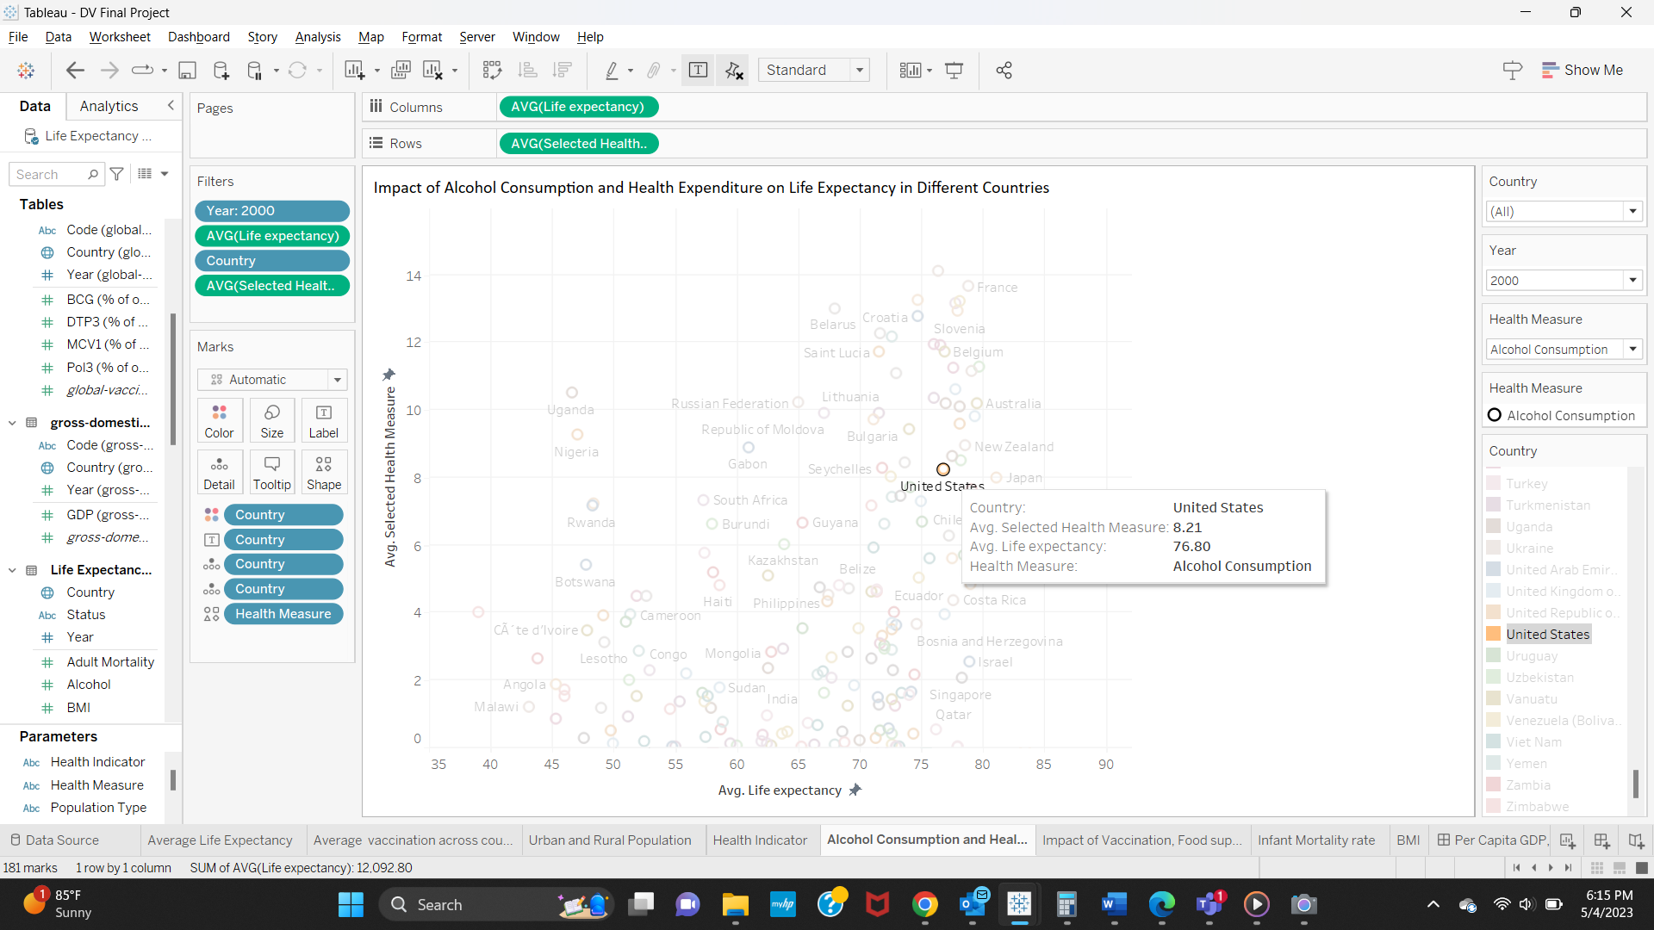

Despite the increase in alcohol consumption, which can be associated with negative health outcomes, the average life expectancy in the United States also increased from 76.80 years in 2000 to 79.10 years in 2014. This suggests that the higher total expenditure on health may have had a positive impact on life expectancy, potentially offsetting the effects of increased alcohol consumption.

This analysis indicates that despite the increase in alcohol consumption, the average life expectancy in the United States has improved. This improvement may be attributed to the increased total expenditure on health, which could have led to better healthcare infrastructure, access to quality medical services, and health promotion programs.

**4)Which health indicators (HIV/AIDS, Hepatitis B, Measles, Polio, Diphtheria) have the most significant impact on life expectancy?**

Our analysis examined the relationship between life expectancy and various health indicators, including HIV/AIDS prevalence, Hepatitis B immunization, Measles incidence, Polio immunization, and Diphtheria immunization. compared these indicators across countries and over time to identify trends and patterns that may suggest a strong association between a particular health indicator and life expectancy.

Our findings indicate that HIV/AIDS prevalence has a significant negative impact on life expectancy, especially in countries where the epidemic is widespread. This is likely due to the high mortality rates associated with HIV/AIDS and the fact that the disease primarily affects younger populations, who would otherwise have many years of life ahead of them. Consequently, a high prevalence of HIV/AIDS can dramatically reduce a country's overall life expectancy.

In 2000, Zimbabwe’s life expectancy was 46 years, with HIV/AIDS at 43.5, WherWhereas2014, the life expectancy increased to 59 years with the fall of HIV/AIDS to 6.33.

In 2000, Zimbabwe had a life expectancy of 46 years, coinciding with an HIV/AIDS prevalence rate of 43.5. However, by 2014, the life expectancy in the country had increased to 59 years, alongside a significant reduction in HIV/AIDS prevalence to 6.33.

The data indicates a significant improvement in Zimbabwe's life expectancy between 2000 and 2014, with an increase of 13 years. This improvement seems to be closely related to the substantial decrease in HIV/AIDS prevalence during the same period, dropping from 43.5 to 6.33. The reduction in HIV/AIDS cases may be attributed to increased awareness, prevention efforts, and better access to antiretroviral therapy. The strong correlation between the decline in HIV/AIDS prevalence and the increase in life expectancy suggests that addressing and managing this health issue has had a substantial positive impact on the overall well-being of the population in Zimbabwe. Immunization coverage for Hepatitis B, Polio, and Diphtheria was found to have a positive association with life expectancy. Higher immunization rates are correlated with lower incidence rates of these diseases, which can directly contribute to improved life expectancy by preventing illness and death caused by these conditions. Measles incidence also appears to be negatively correlated with life expectancy, although the impact may not be as pronounced as that of HIV/AIDS.

In conclusion, our analysis suggests that among the health indicators examined, HIV/AIDS prevalence has the most significant negative impact on life expectancy, while immunization coverage for Hepatitis B, Polio, and Diphtheria has a positive association. It is crucial to emphasize the importance of preventive measures, such as vaccination programs, in improving life expectancy and overall population health.

**5)How has the infant mortality rate changed over time for different countries?**

Our analysis explored the changes in infant mortality rate (IMR) across different countries over time. The infant mortality rate is a key indicator of a country's overall health and development, as it reflects access to healthcare, socioeconomic conditions, and maternal health, among other factors. By examining how IMR has evolved in various nations, can gain insights into their progress in addressing critical health issues and improving population well-being.

Our findings reveal that, in general, there has been a significant decline in infant mortality rates worldwide over the past few decades. This trend is observed across both developed and developing countries, indicating a global improvement in healthcare access, quality, and the effectiveness of interventions aimed at reducing infant mortality.

Over time, health outcomes have significantly improved in India, a developing nation. One significant finding is the drop in infant mortality, which can be linked to several things, including better healthcare infrastructure, greater access to healthcare services, and better mother and child health education. In parallel, India's life expectancy has also been increasing, suggesting that people are living longer, healthier lives.

It is possible to relate improvements in medical technology, public health initiatives, and raised knowledge of the value of immunizations and preventive measures as the cause of this positive correlation between a decline in infant mortality and a rise in life expectancy. Additionally, the government's initiatives to prioritize health and well-being by funding healthcare systems, advancing health education, and strengthening social determinants of health have been essential to these advancements.

The review of India's health situation illustrates the importance of a multifaceted strategy for enhancing the general health and well-being of a community. When paired with other factors, the decrease in infant mortality and the rise in life expectancy are indicators that can improve a country's health results.

Over the years, healthcare outcomes have significantly improved in the United States, a developed nation. The significant decline in newborn mortality rates is one of the most impressive accomplishments.

There are several reasons why there has been a drop in infant mortality and an increase in life expectancy in the US. These include ongoing medical innovation and research, comprehensive public health regulations, and a focus on early detection and preventive care. To further safeguard the well-being of its population, the US government has been actively investing in healthcare infrastructure, encouraging health education, and tackling socioeconomic determinants of health.

## **Conclusion**:

The association between life expectancy and several variables, such as newborn mortality rates, the distribution of the population between urban and rural areas, alcohol use, total health spending, and other factors, has been examined in this study. The investigation showed that important influences on life expectancy include things like vaccination rates, urbanization, health spending, and particular health markers. Additionally, the improvement in life expectancy in many nations has been facilitated by a decline in infant mortality rates over time. The goal of this study was to investigate worldwide health trends, with an emphasis on life expectancy and its associations with various socioeconomic, demographic, and health variables. I looked at how life expectancy was affected by things like vaccination rates, the proportions of urban and rural residents, alcohol use, health care costs, and health indicators including HIV/AIDS, Hepatitis B, measles, polio, and diphtheria. I also looked at how infant mortality rates have changed over time for various nations.

The differences in life expectancy seen in various countries highlight how crucial it is to comprehend how these factors interact and how they affect general health and well-being. Policymakers and public health specialists can create targeted interventions to improve health outcomes and improve the quality of life for individuals all over the world by identifying the major factors influencing life expectancy and addressing inequities. This study lays the groundwork for additional investigation and analysis, which is essential for developing practical solutions to the many problems that face global health today.

Our findings demonstrated that a complex interplay of variables, including healthcare availability and quality, socioeconomic circumstances, and population health status, affects life expectancy. For instance, it was shown that vaccine coverage was positively correlated with life expectancy since nations with greater immunization rates typically had better health results. A higher proportion of urban residents was frequently associated with longer life expectancy, possibly because of better healthcare availability and livability in cities.

🡪The relationship between life expectancy and vaccination coverage. Our analysis shows a positive correlation between vaccination coverage rates for BCG, MCV1, Pol3, and DTP3, and life expectancy in different countries. This suggests that as vaccination coverage increases, life expectancy is likely to improve, highlighting the importance of immunization programs in promoting health and preventing diseases.

🡪Next, I found that countries with higher urban population percentages generally have higher life expectancies. This could be due to better access to healthcare, sanitation, and other essential services in urban areas. However, it is important to recognize that there are still significant disparities in life expectancy within both urban and rural populations, indicating that other factors may also play a role.

🡪 I also examined the impact of alcohol consumption and total expenditure on health on life expectancy. Our findings indicate that countries with higher alcohol consumption rates tend to have lower life expectancies. On the other hand, countries with higher total healthcare expenditure generally have higher life expectancies, suggesting that investing in healthcare can contribute to better health outcomes and longer life spans.

🡪In our analysis of health indicators, I found that HIV/AIDS has the most significant negative impact on life expectancy among the diseases I studied, followed by Hepatitis B, Measles, Polio, and Diphtheria. This emphasizes the importance of continued efforts to combat these diseases through prevention, early detection, and treatment to improve overall life expectancy.

🡪I also analyzed the change in infant mortality rates over time for different countries. Our findings show a general trend of decreasing infant mortality rates, which has contributed to the increase in life expectancy. This improvement can be attributed to better healthcare, access to vaccinations, and improved living conditions in many countries.

On the other hand, several health metrics, including a high prevalence of HIV/AIDS or a high newborn mortality rate, were linked to shorter life spans. This emphasizes how critical it is to treat these health issues to raise the general level of population well-being. I also noticed a global drop in infant mortality rates, which is a result of better access to, and the caliber of, healthcare services, as well as preventative measures.

To ensure the well-being of populations around the world, policymakers and public health practitioners must prioritize increasing vaccination coverage, addressing disparities in access to healthcare between urban and rural areas, promoting responsible alcohol consumption, increasing investment in healthcare infrastructure, and addressing common health issues. Additionally, by comprehending these relationships, governments, and international organizations can create focused interventions that address the difficulties each country faces.

In conclusion, this investigation emphasizes the complexity of life expectancy and its many contributing factors. To overcome gaps and further enhance health outcomes around the world, it underlines the significance of ongoing investments in healthcare infrastructure, mother and child health programs, and focused interventions. Future studies should look more deeply into elements and how they affect life expectancy, as well as examine regional differences and the role of policy interventions in driving positive change.

**Future Research Questions:**  
1) How do cultural factors (such as diet, lifestyle, and social support) impact life expectancy across countries?

2) How does income inequality affect life expectancy? Is there a correlation between income distribution and life expectancy in different countries?

3) What is the relationship between government healthcare expenditure and life expectancy? Do countries with higher healthcare spending tend to have higher life expectancies?